Question 1 :

For a string S, find the length of the longest substring with unique char in it

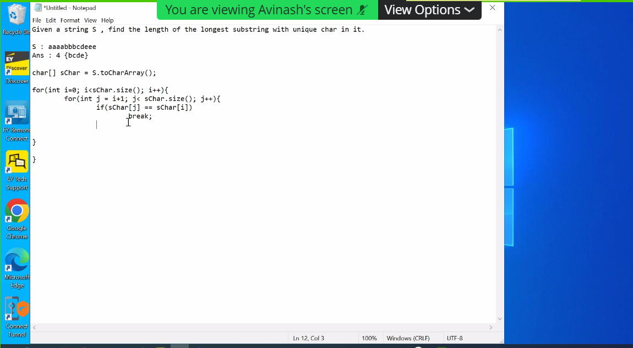

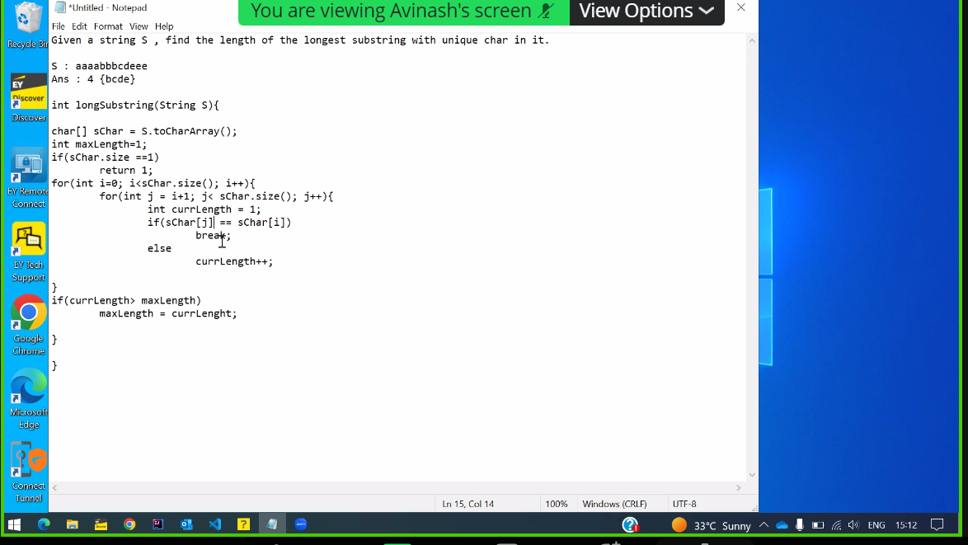

Panel : Can you trace this with sample

If I =0 and j =2

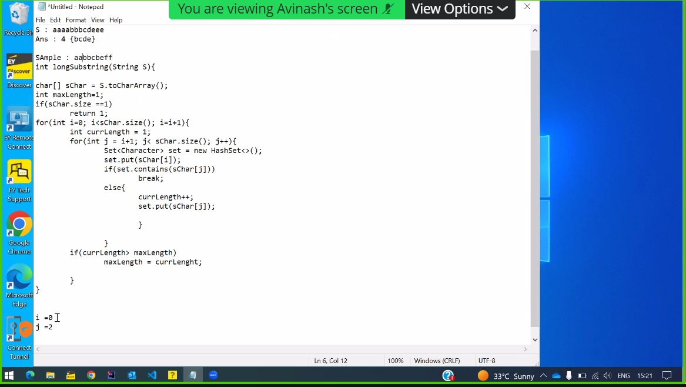

Panel : How current length can be 3 , it should be zero

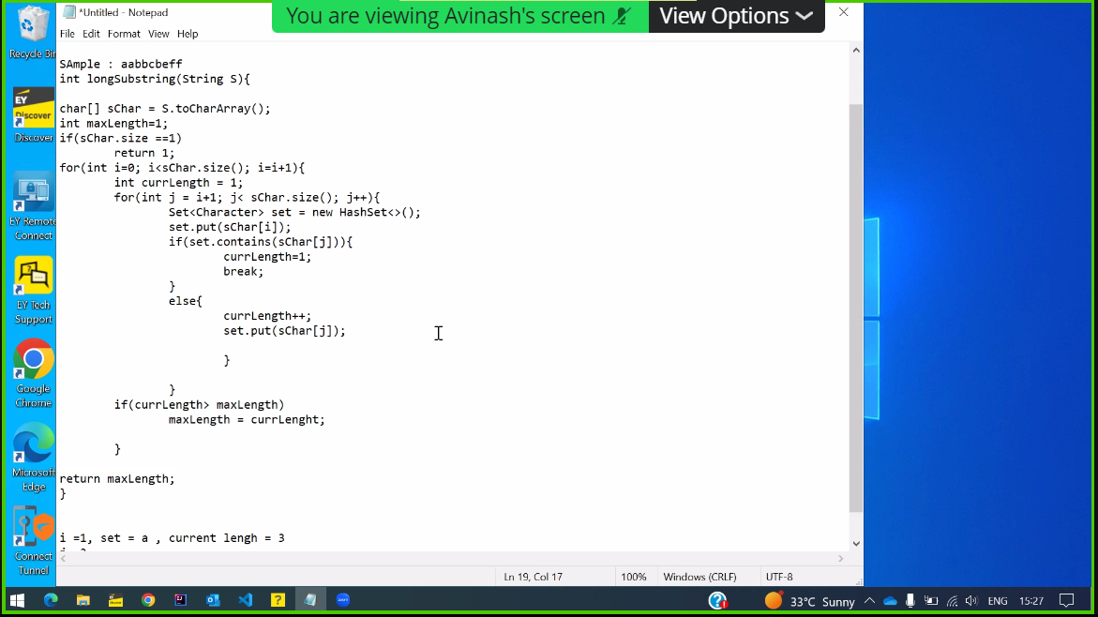

**Question 2:**

Given a N , Find a number whose sum of digits is equal to N and is the smallest number possible

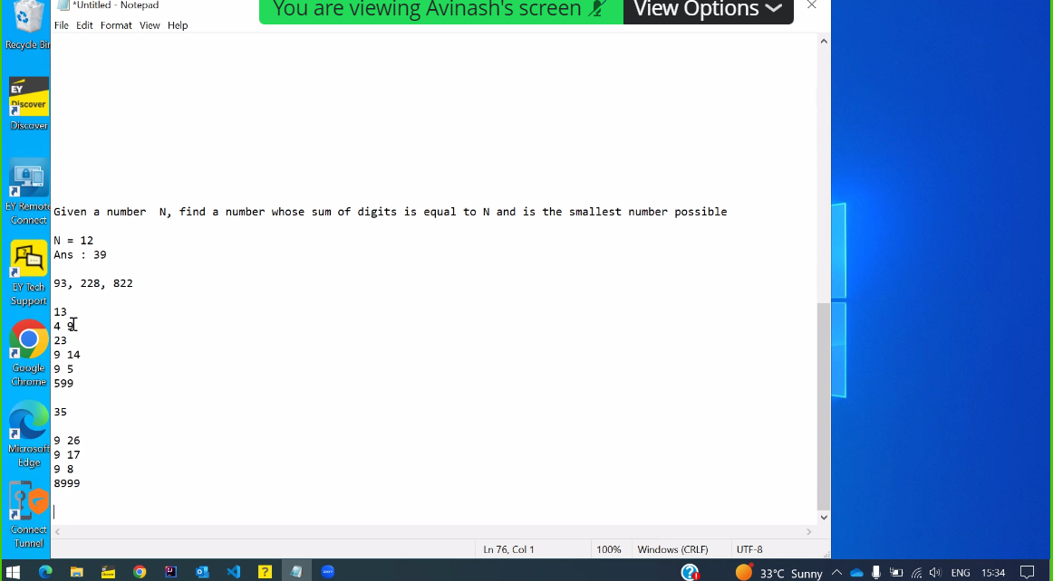

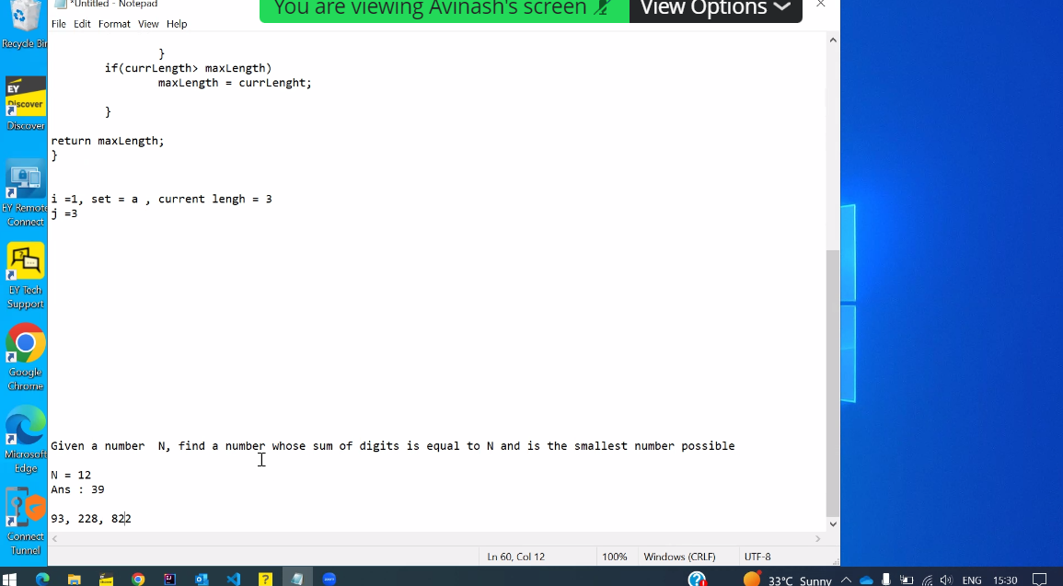

Question 3:

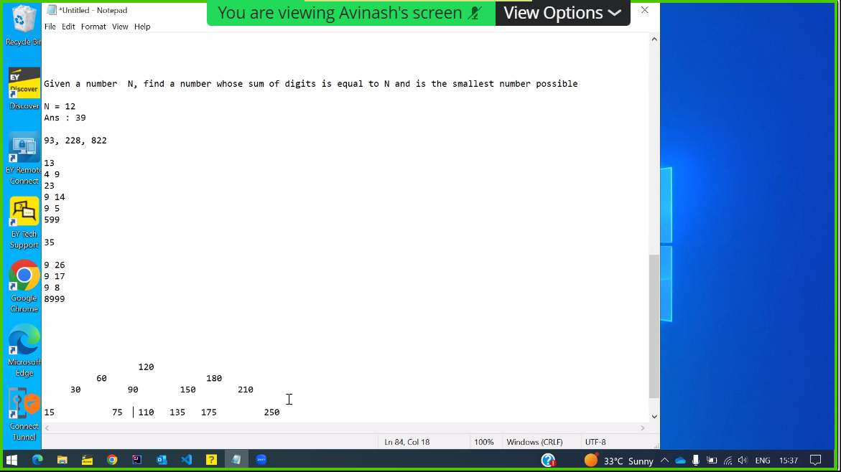

Q4 : How does Autowired works?

Q5: what if we don’t use

Q6: Different annotations that you come across

Q7: Does repository provides different component

Q8: Any other annotations ( @ configuration)

Q9: Have you used (@Sync )

Q10: Why do we basically use (@Sync )

Q11: Have you used Kafka

Q12: Different Types of Kafka Components

Q13: Why do we use ZooKeeper?

Q14: What is the role of brokers?

Q15:What are partitions?

Q16: Why do we use multiple partitions?

Q17: What is the role of Key?

Q18: Can we set same key for the partitions?

Q19: 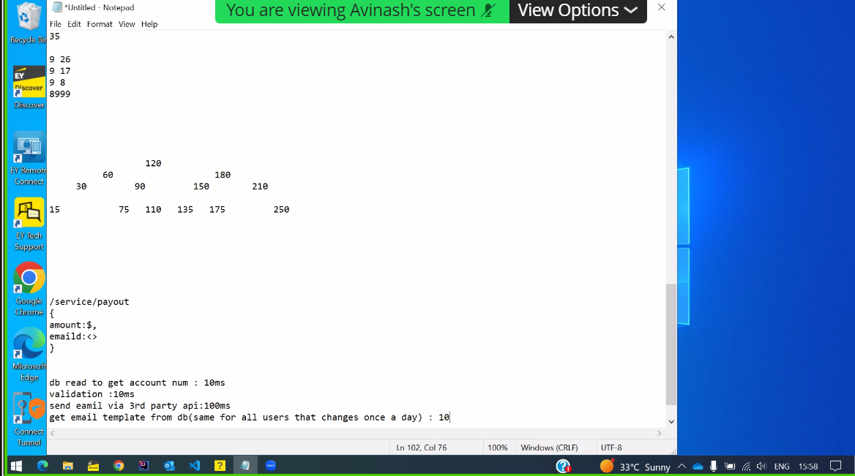

Q20: 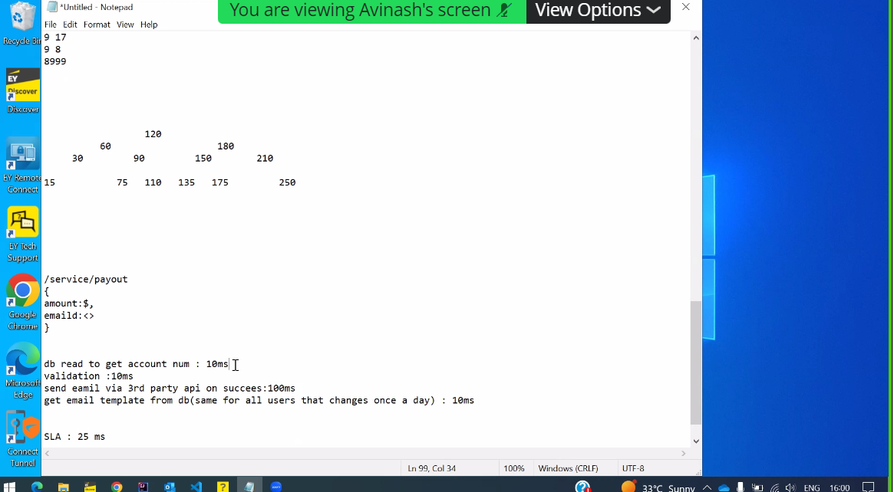

Q21: Given with response

Q22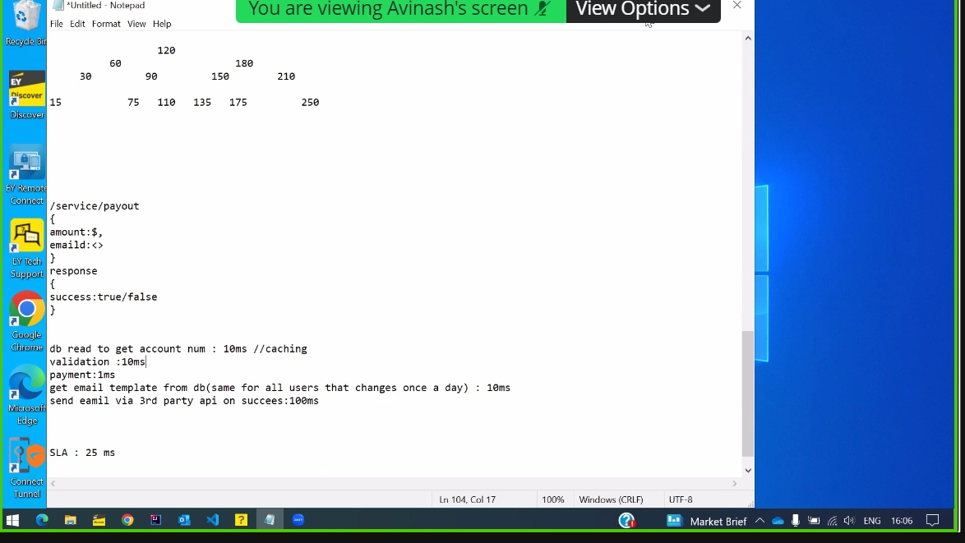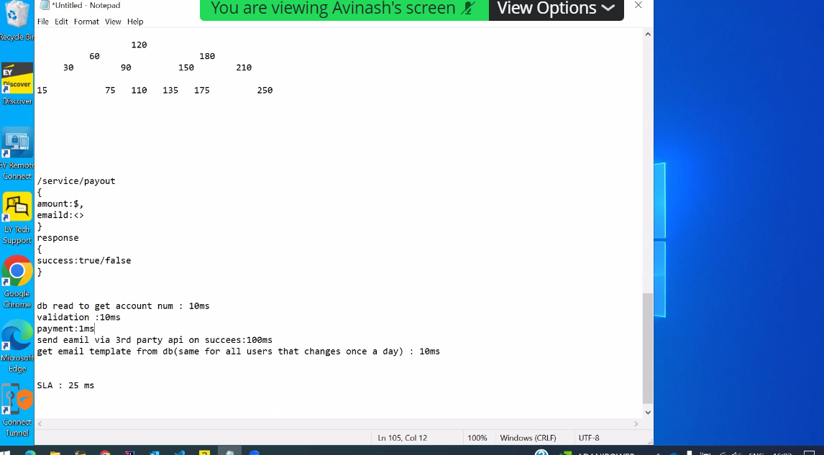

**Client Level 2 :**

**Date: 2- Mar-2022 (Panel Ameeta)**

Q1 : Introduction

Q2: Experience over migration

Q3: 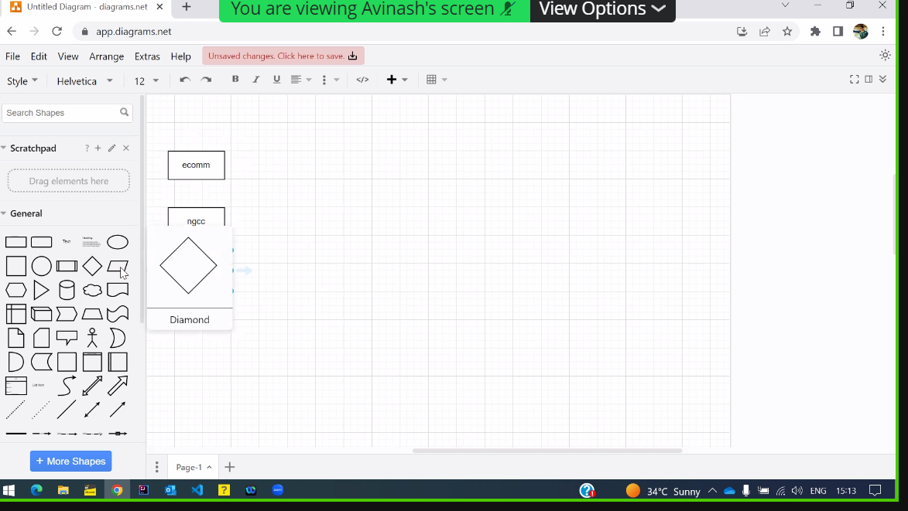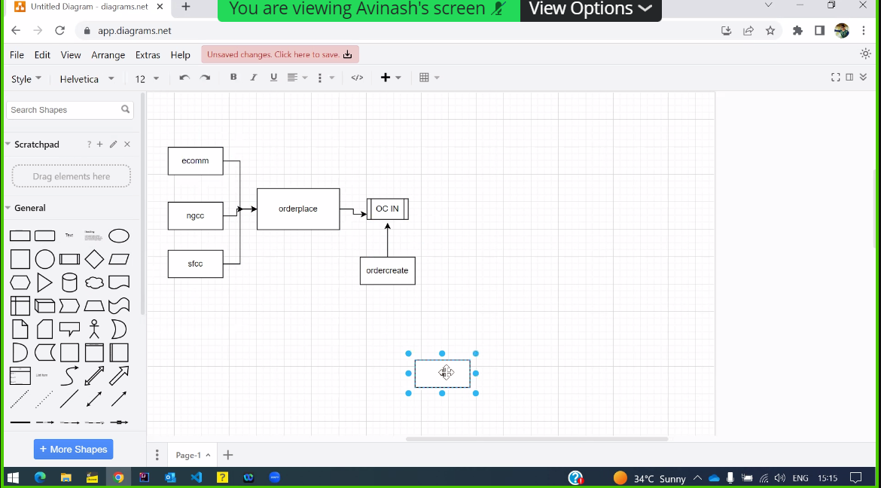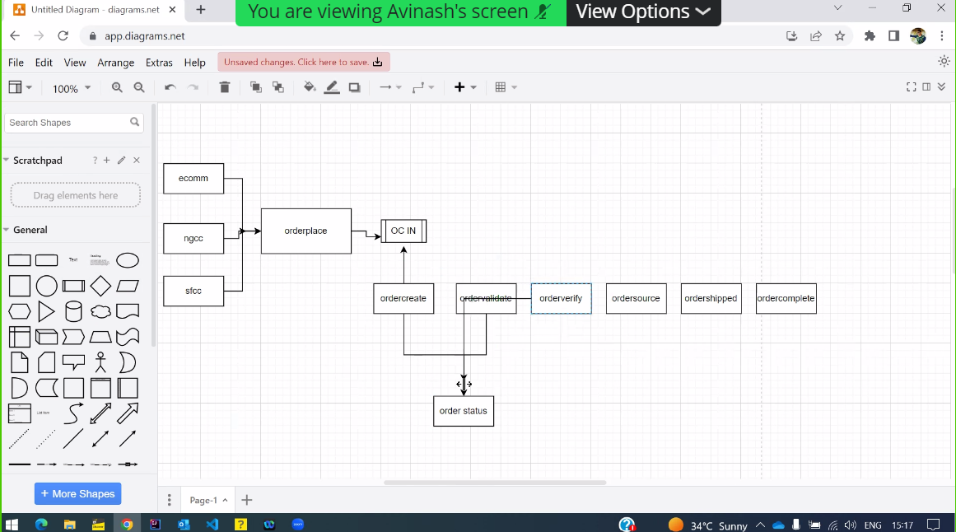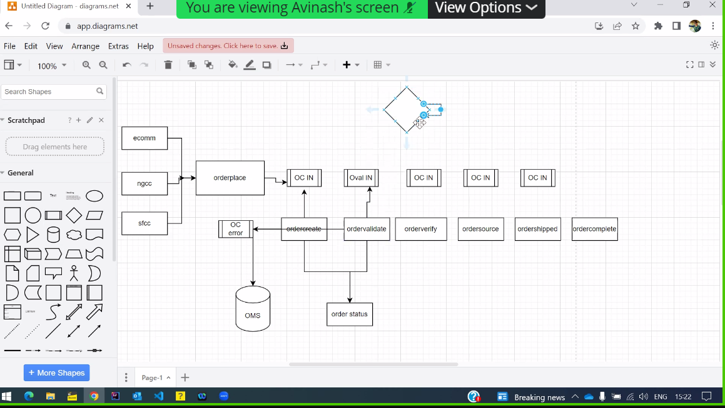

Candidate briefly explaining

Q3: What are the tech stacks involved in the Flow

(Camel,Audit Microservices,Spring Boot, Kafa)

Q4: Do you have experience Hibernate? How would you explain Hibernated to a new comer?

Q5: What is named Parameters ? When should we use ? Explain with Example

Q6: 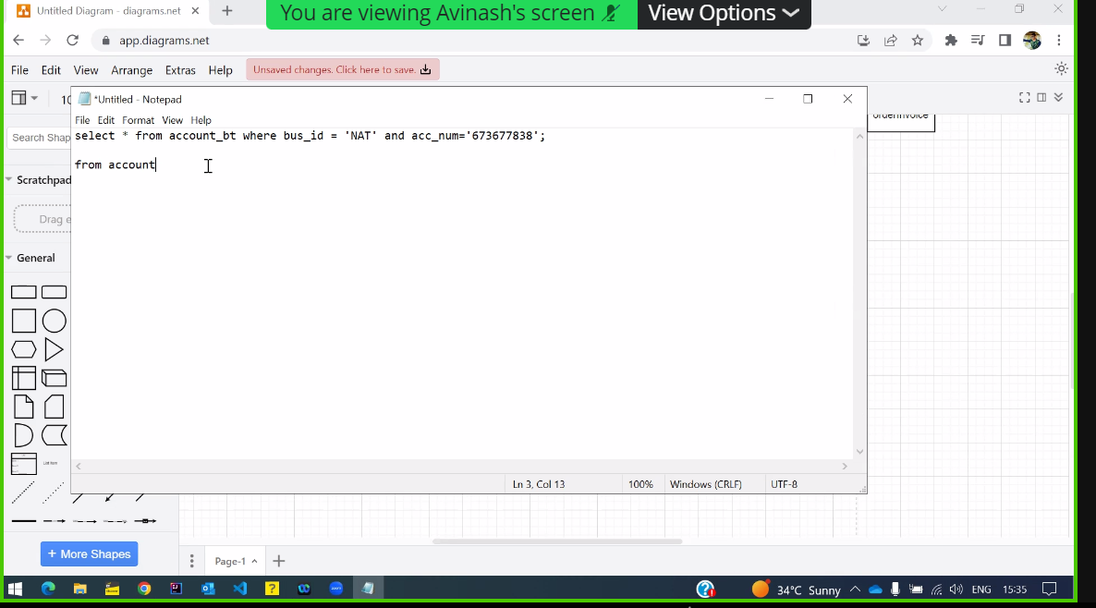

Q7: Scenario base Question ( How would you handle if many order Comes)

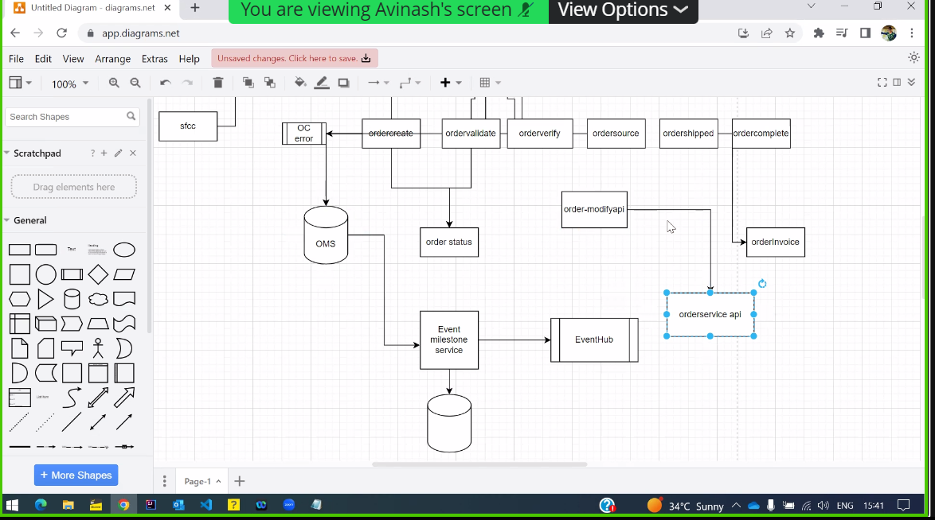

Q8: (Java Coding) Count on the no of platforms needed 9:00 - 9:30, 10:00- 10:30, 9:45- 1:30

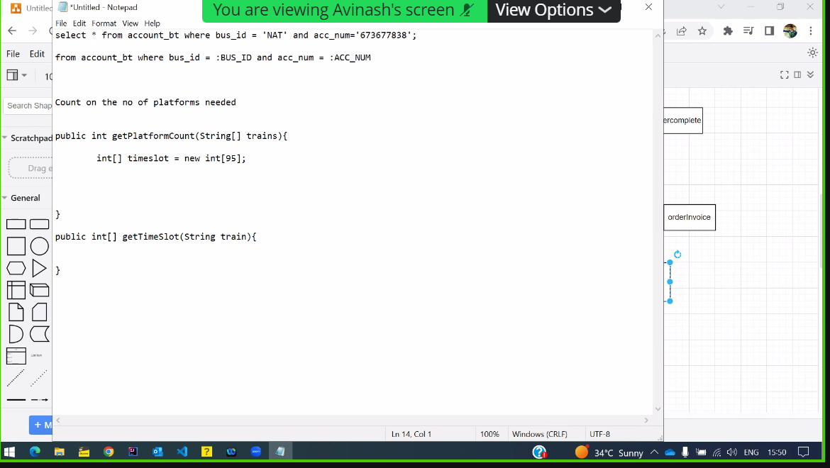

Q5: What is the reason you are looking out

Client Interview Question : 21/3/23 – L1

Q1: Self Introduction

Q2. How was storage Scheduled

Q3.What kind of alert you find

Q4.Where was it deployed

Q5.If you are given a API In performance test.

Q5.What are Query execution

Q6. Can we use JMeter in memory footprint

Q7.Explain Garbage collections

Q8. Can we kill a running thread in java

Q9 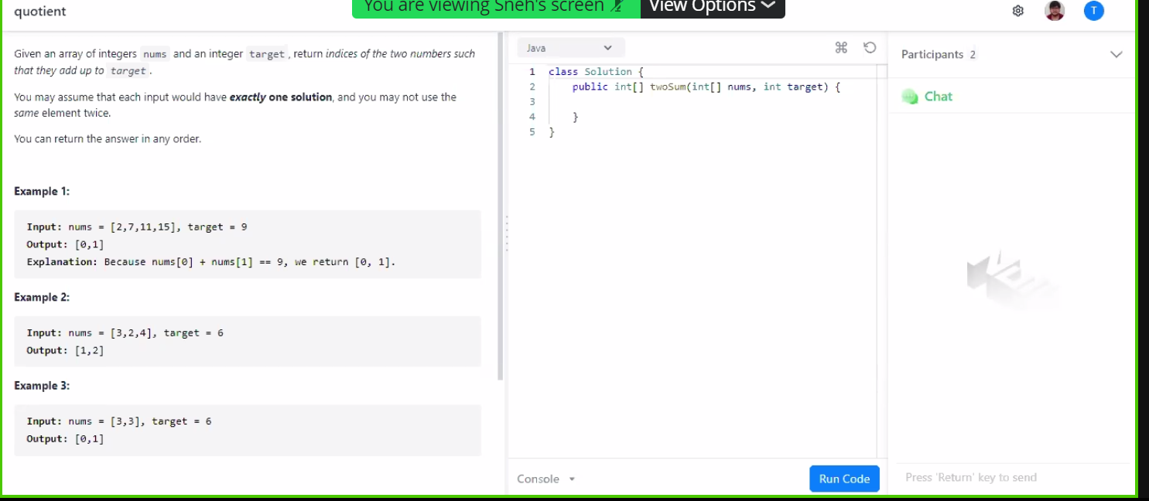Q10.Cuncurrent mass 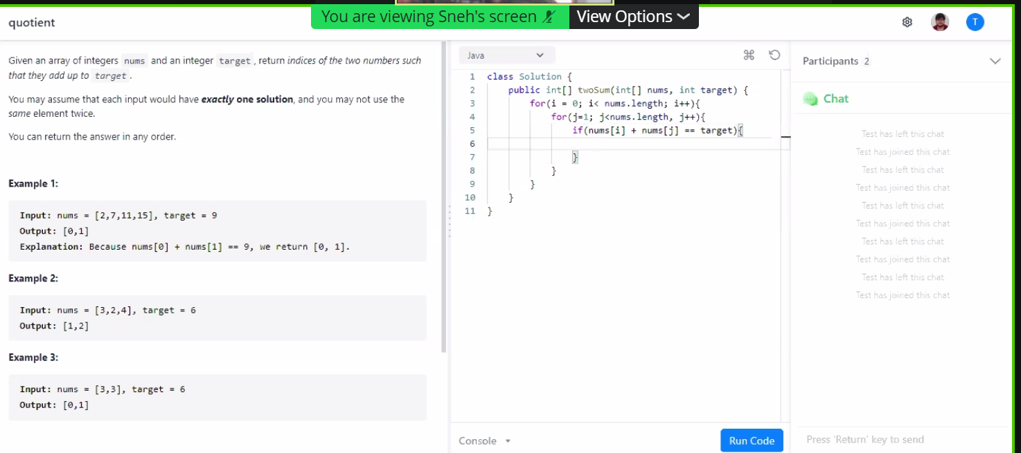Q11

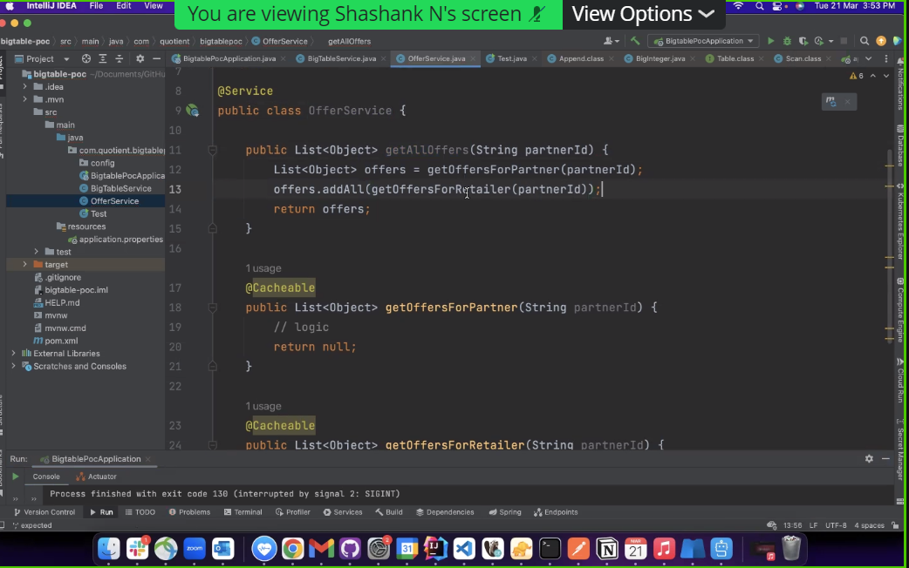

Q12. How are annotations implemented in A-Sync

Client Interview Questions : L1

Q1: Introduction

Q2: Front End Knowledge

Q3: Architects involved and teckstacks

Q4: 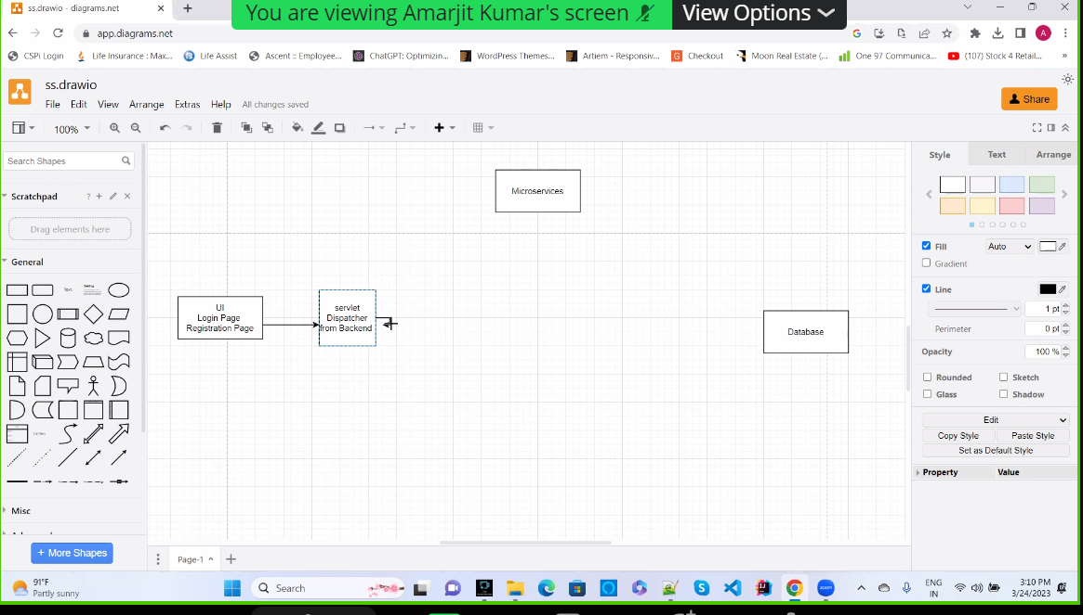

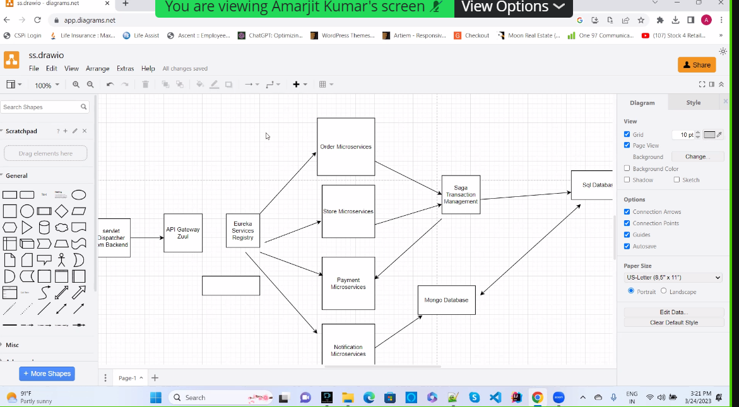

Q5: What are the difference between architecture and springmvc

Q6:What is the difference btw in property file and AML

Q7.If payment is down , how will you handle it

Q8. About Kafka Clusters

Q9. How do you configure Kafka

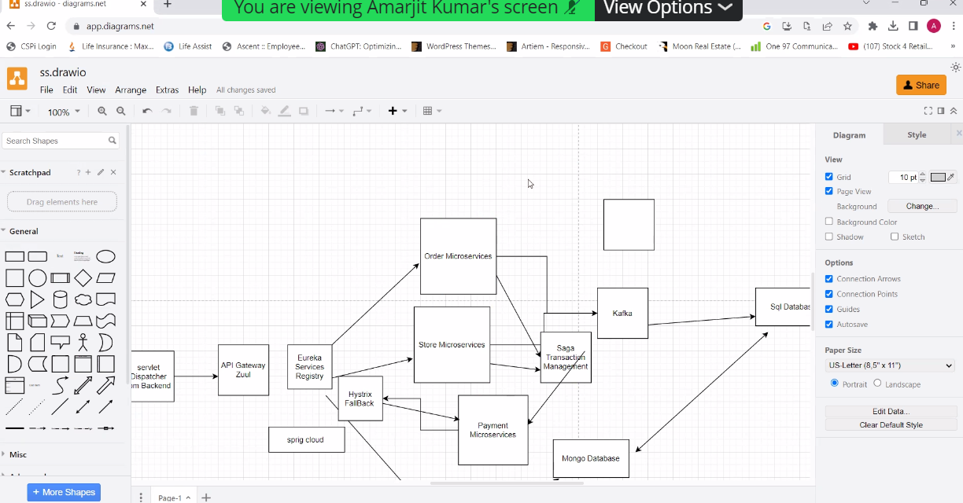

Q10.Which Java Version You were using and its Editions

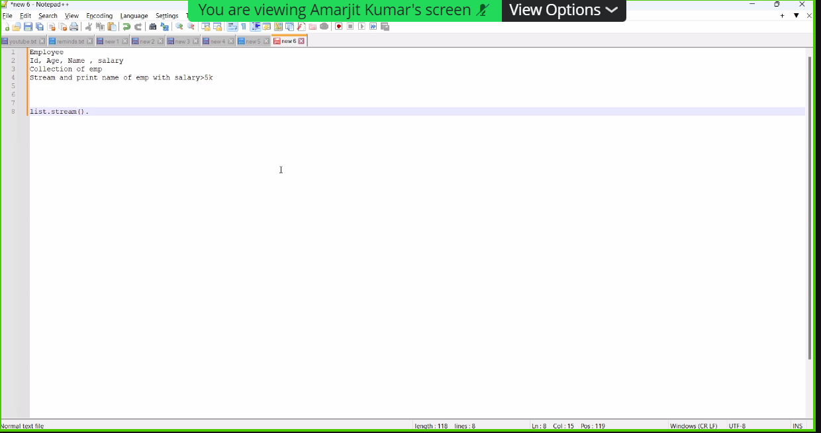

* Docker and image file config?
* Development flow? Git workflow
* Git branching strategy? What if multiple features happening in parallel
* What we will go with a new code repo
* API optimization - API is taking time?
* What is the approach to optimize the query?
* How can we see query using the indices? Query execution plan?
* Redis Sentinel
* Multiple nodes of Redis? How the requests are served with multiple nodes
* Multi-threading? Optimization
* How would you optimize when we have multiple API calls? Like 4th API need data from first 3 APIs. How threading will be implemented for this.
* Thread pools? Types?
* Compute intense and IO intense tasks? What will be the thread pool?
* Will the thread pool different for compute and IO?
* Design Patterns? Singleton? How it is created?
* What will happen two threads tries to creates a singleton class same time?
* How to stop serialization for Singleton class?
* Where did you use Kafka? What events used? Partition in Kafka?
* Spring Beans? Bean Scope?
* Serverless?
* Write the logic. Time complexity improvement.

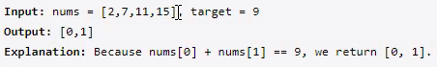

* Java Memory architecture? Garbage collector? How Garbage collector knows which object to removed? What is the GC mentioned in your application?
* Extends Vs using object as a variable in derived class?
* Application monitoring tools? How will track the API flow?